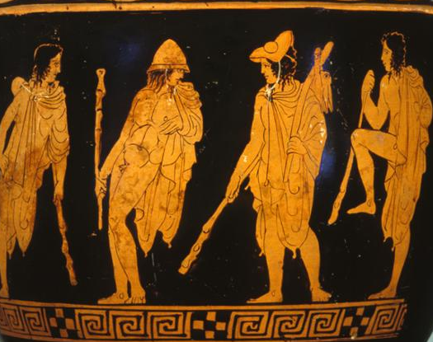 |  | What are you wearing?
Classical World, Native American Voices, China |  | 50 minutes

This lesson is designed to help students integrate vocabulary related to clothing into everyday conversation. Using the artifacts in the galleries as cultural examples, students can examine clothing, describe what they see, and understand the importance of costume and adornment in the past.

Vocabulary List

- Clothing items: dress, shirt, skirt, tunic, shroud, cloth, blouse, vest, robe, hat, shield, boots, sandals, necklace, earrings, bracelet, belt, buckle
- Clothing descriptors: color, loose, fitted, shiny, soft, rough, smooth, textured, heavy, light, airy, itchy, draped, tied, woven, dyed, hand-made, sewn, traditional, long, short
- Material: metal, bronze, fabric, wool, cotton, leather, beads, ceramic, polyester, stone, animal skin
- Body parts: arms, legs, torso, neck, shoulders, knee, foot, head, hand

The Museum Visit

Explore the Gallery (5-10 minutes)
Give the class a few minutes to explore one of the suggested galleries. Draw their attention to clothing and other items of dress.
Introductory Group Discussion (15-20 minutes)
Gather students around one of the suggested objects for group discussion. Possible questions include:
- What color is it?
- What is it made of?
- Who might wear this?
- What does the clothing tell you about the person who might wear it?
- What parts of the body are covered/showing?
- Are there any patterns or details on the clothing?

Partner/Small Group Work (10-15 minutes)
Have students break into partners or small groups to explore the gallery, selecting an object or objects that they find interesting on which to take notes.

Final Discussion (5 minutes)
Gather students for final review, questions, and to give instructions for the post-visit assignment.

recommended objects

Native American Voices
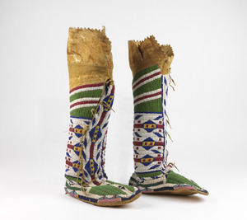

Woman’s Moccasins (NA 3498)

Man’s Big Shirt (29-47-26)

Woman’s Dress (29-47-25)

Squash Blossom Necklace (91-35-1)

Concho Belt (74-10-2)

China Gallery

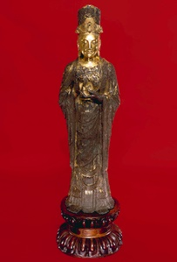

Bodhisattva Guayin (C400)

Lokapala (40-35-2)

Bodhisattva (C451)

Lokapala and Officials (C401)

recommended objects

Classical World Galleries
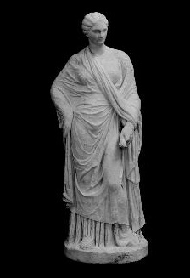

Marble-draped Statuette (MS5681)

Apulia Red Figure Amphora (31-36-17)

Attic Black Figure Amphora (MS5467)

Grave Stele (MS5470)

Mortuary Statue (B8904)

Post-Visit Activities

Red Carpet Event
Have the students break into pairs- one interviewer and one interviewee. The interviewee will pretend to be wearing one of the clothing items from the gallery. The interviewer will ask questions about the piece, such as: where is your outfit from? Who designed it? How is it made? Why are you wearing it?

Writing Assignment
Encourage students to choose an object from the Museum’s collection and write a paragraph describing it. The descriptions should answer questions such as: What is the garment made of? What does it look like? Who may have worn it?
Questions?
Ready to schedule a visit?
Contact Penn Museum’s Academic Engagement Department at
classuse@pennmuseum.org

